Expression of Interest 24024
Grazing of Paddocks – Part of Lot 127 on SP203119, Mitchell

- Introduction
Maranoa Regional Council is calling for expressions of interest from persons wishing to enter a licence agreement to keep and graze horses in paddocks 1, 2, 3, 4 one-acre blocks located in Mitchell, as shown on the attached map.

- Background
Council owned freehold land located at Saleyards Road, Mitchell, has been subdivided into a number of one acre paddocks suitable for keeping and grazing one horse per paddock.

- Details of Paddocks
3.1 Area
- 1 Acre, Paddock 1 – 4
3.2 Access
- Access to the laneway that leads to each paddock is through Maranoa Pony Club grounds.

  - Fencing

- Each paddock is fully fenced with 4 strands barb wire and star pickets.

  - Water

- Water is connected to each paddock.
- Each paddock contains a trough and gate.

- Map

Map below showing the proposed four, 1 acre paddocks on Lot 127 on SP203119
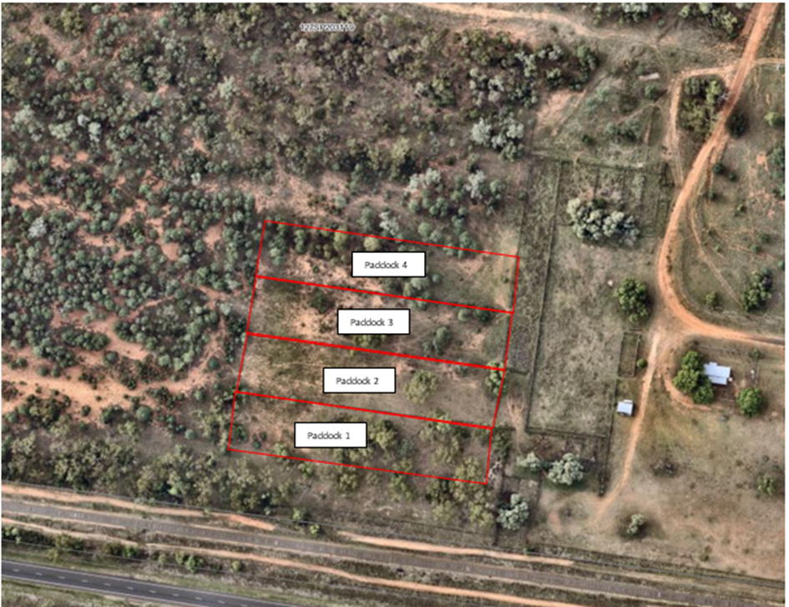

- Price

One acre blocks - $9.00 per head per week. $468 per annum.
Bond $525 per paddock

- Term
One (1) year period.
- Registration of Interest
To register your expression of interest please complete the attached form and return to Council by close of business on Friday 6 October 2023.

Expression of Interest
Grazing of Paddocks – 1 Arce, Saleyards Road, Mitchell

Name
Address | Street Address  Postal Address
Contact Details | Phone  Email
Preferred Paddock  (List in order of preference) | One acre Paddock 1 – Preference No  Paddock 2 – Preference No  Paddock 3 – Preference No  Paddock 4 – Preference No
Number of Horses to be kept on property  Note – no stallions or rigs allowed | Only one horse per one acre paddock

Comments (if any) to further support your expression of interest

I hereby submit my Expression of Interest in grazing horse/s at a Council owned paddock off Dargal Road, Roma. If successful in my application, I agree to enter into a licence agreement with Council and abide by all terms and conditions contained in the licence agreement.
I acknowledge that Council may receive more Expressions of Interest than there are paddocks available. Also that Council’s final decision in regard to paddock allocation may take into account a range of factors including number of horses proposed to be grazed, and Council’s original intention in offering the land being to provide space for local horse owners to keep horses outside the town area.

(Signature) (Date)

Completed form to be returned to –
Maranoa Regional Council, PO Box 42, Mitchell Qld 4465
or scan completed form and email to council@maranoa.qld.gov.au
Expressions of Interest must be received by Council by Friday 06 October 2023

Grazing Agreement
For Keeping of Horses

The Licensor: Maranoa Regional Council

and

The Licensee: [Name]
Date: [Date]
The date is: | [date]
The Licensor is: | Maranoa Regional Council
Of | PO Box 42 Mitchell QLD 4465
The Licensee is: | [name]
Of | [address]
The Land is: | Land described as paddock number [?], being part of Lot 127 on SP203119 as shown on the attached map.
Period of Licence: | 12 months starting from [date].
Number of Horses to be kept on the Land: | A maximum of 1 horse to be kept on the land at a total cost of $468.00 per year (12 months) inclusive of GST for the term of the Licence.
Bond: | Bond payable $525 to be held in trust by the Licensor.
Terms of the Agreement

Price
  - This agreement is for grazing horses on the Land.
  - The price for grazing of the land is $468.00 per year (12 months) (“Price”).

The grant
  - For the Price, the Licensor grants to the Licensee the personal right of access to the Land for grazing its own stock, for conservation of the pasture and for no other purpose for the term of the Licence.
  - This Licence does not create a right of exclusive occupation of the Land by the Licensee or any interest in the Land.

Payment
  - The Price shall be paid by quarterly instalments, payable in advance before the commencement of each quarter.

Use of services

The Licensee may use a reasonable amount of water, obtained from the service provision on the Land, but the Licensor may in its absolute discretion charge the Licensee for use of such services if it considers such use to be excessive.

Condition and repair

In relation to the Land, the Licensee must:
  - maintain the state and condition of the Land;
  - maintain the fences, gates, locks, structures and other fixtures or installations in the condition in which they are at the commencement of this Licence, at all times.
  - maintain water infrastructure and pipework located within the Land .
  - The Licensor reserves the right to monitor pasture levels and may direct the Licensee to reduce the stocking density of the Land, if necessary.

Restrictions on Licensee

In grazing the Land, the Licensee agrees that it will not:
  - construct any building or structure on the Land;
  - deposit or bury any rubbish on the Land;
  - accumulate or allow to accumulate anything on the Land, the accumulation of which could contravene any law, rule or regulation;
  - bring onto or allow to remain on the Land any animal infected with a contagious or notifiable disease. The Licensee must notify the Licensor immediately if any horse suffers or has been in contact with any significant or notifiable sickness, disease or injury. If the Licensee fails to obtain veterinary assistance for any sick animal, the Licensor may engage veterinary assistance and invoice the Licensee all veterinary and other charges incurred;
  - introduce any disease affecting the Land;
  - store on the Land any machine or vehicle;
  - bring onto or store on the Land any goods whatsoever except goods connected with the Licensee's grazing of the Land;
  - spray any chemical on the Land without the express written consent of the Licensor;
  - contaminate or obstruct any waterway running through or adjacent to the Land;
  - waste water;
  - obstruct any private or public right of way or any access by any other party to any other land belonging to the Licensor;
  - cause a nuisance to the Licensor or any other person;
  - attempt to establish entitlement to single payment nor make any claim for that payment in respect of the Land;

But the Licensee will:
  - stock the Land with its own horses (other than a stallion or rig), in such number as is permitted by the Licensor , in order to prevent damage to the grassland, considering the type, quality, productivity and drainage of the soil;
  - ensure an adequate supply of water is always available to its horses;
  - maintain the perimeter fence of the Land ;
  - comply with all laws, standards and guidelines for animal welfare, bio-security and stock management and prevent stock from straying away from the Land.
  - comply with any limitations on stocking density, mowing, fertilising, spraying and management imposed by the Licensor as a local government authority;
  - report any leak of water to the Licensor;
  - slash the paddock if not grazed to a level satisfactory to the Licensor;
  - keep the Land clean and free from noxious weeds;
  - not allow horse droppings to accumulate;
  - ensure all vaccinations and other treatments required by good husbandry have been given to animals at the appropriate times prior to delivery of the animals to the Land and during the term of this Licence.;
  - remove the carcass immediately if any animal dies on the Land.
  - ensure the Licensor has current contact details for the Licensee and the Licensee’s preferred veterinarian at all times in case of emergency.

Licensee's indemnity

The Licensee agrees to indemnify the Licensor against all costs claims and expenses arising from any act or omission of the Licensee in connection with the Licensee's use of the Land whether or not it is in breach of this Licence.

Access for Licensor

The Licensor at its own discretion may maintain and improve the pasture and repair, maintain, alter and erect any buildings, fences, gates, boundaries and ditches and other fixed equipment but must not graze animals other than horses or mow the pasture.

Transfer and alienation
  - The Licensee must not permit any other person to occupy the Land.
  - The Licensee is not granted any interest in the Land capable of transfer or alienation.

Termination
  - The Licensor may terminate this Licence on giving 48 hours’ notice at any time it is of the opinion that the Licensee is in breach of this Licence.
  - Either party may terminate this Licence upon three months’ notice given at any time, without giving a reason. No compensation shall be payable to the Licensee.
  - The termination of this Licence does not cancel any outstanding obligation of the Licensee.
  - Upon termination of this Licence, the Licensee shall vacate the Land, leaving it in the state and condition in which this Licence requires. In particular, the Licensee will leave no hay, straw, fencing materials or detritus of any sort and all fences must be in the condition they were at the commencement of this Licence.

Other matters
  - The Licensee may insure its animals and goods on the Land. The Licensor is under no obligation to maintain insurance and is not responsible for any loss or damage to the Licensee's property or goods.
  - The Licensee must hold public liability insurance for an amount of at least $20 million to cover the rights and interests and the liabilities to third persons, of the Licensee concerning occurrences on the Land,or the presence of horses on the Land or the escape of horses from the Land.
  - If the Licensor makes any concession in respect of any right it has under this Licence, that concession, shall not be taken to reduce its rights under this Licence.
  - If an employee of the Licensor is present on the Land at any time, this is without legal obligation to the employee or the Licensor and the Licensor accepts no liability for any accident, straying, death, illness or damage caused by or to the Licensee's stock.
  - The Licensor shall have a lien upon all the Licensee's animals for the time being on the Land for any sum owing or expense incurred for which under this Licence the Licensee is liable and this lien may be enforced by the sale of any such animal.
  - The Licensor may apply the bond towards payment of any monies owed under this Licence by the Licensee or towards any cost incurred by the Licensor as a consequence of a breach of this Licence by the Licensee.

Signed by the parties:

Licensor’s signature ___________________________________

Chief Executive Officer, Maranoa Regional Council

Licensee’s signature ___________________________________

