Tender Documents

Part 1 - Invitation to Tender,
Tender Specification &
Tender Response

Request for Tender
(RFT)

Closing Time:

RFT Number:

23009

10 am
(Australian Eastern Standard Time)
03 October 2022
Sale of 236 Edwardes Street North, Roma QLD 4455

INTRODUCTION

Maranoa Regional Council invites tenders for the sale of house and land located at 236 Edwardes Street North, Roma Qld 4455 and described as Lot 1 on SP295224.
The Property located at 236 Edwardes Street North, Roma Qld 4455 and described as Lot 1 on SP295224 is zoned as “Rural” in the Maranoa Planning Scheme 2017.

The Property is comprised of 1,759m2 land area. The building is a lowset, single dwelling with concrete and timber flooring, chamferboard and hardiplank external walls, timber framed windows and corrugated galvanised iron roof sheeting. Internally the home is lined with VJ lining boards and fibrous cement sheeting.
Please note that this building contains asbestos!
The property is located within the known flood zone and mapped as having ‘Low’ Flood Hazard.
The property is offered on an “as is” basis and tenderers must undertake their own investigation in relation to the adequacy of the property for their requirements.

Inspections via prior appointment. Appointments to be made via Council's customer service 1300 007 662.

After the evaluation, and if a suitable Tenderer is selected, Council will prepare an REIQ Contract for signature by both parties.
Tender Number: | 23009
Closing Time: (clause 1 – Conditions of Tender) | 10 am (Australian Eastern Standard Time)  03 October 2022
Tender Lodgement | procurement@maranoa.qld.gov.au  or www.vendorpanel.com.au
Tender document Location | Council land for sale in Roma by tender – Maranoa Regional Council  Or  www.vendorpanel.com.au
Optional Site Visit (clause 3.9 – Conditions of Tender) | Location: 236 Edwardes Street North, Roma Qld 4455  Inspections via prior appointment. Appointments to be made via Council's customer service 1300 007 662.
Tender: (clause 1 – Conditions of Tender) | Part 1 - Invitation to Tender & Information for Tenderers  Part 2 - Conditions of Tender  Part 3 - Specification  Part 4 - Tender Response
Tenders must be open for acceptance for this amount of time: (clause 7.5 – Conditions of Tender) | 90 days from the Closing Time
Evaluation criteria and weightings (points) to be applied: (clause 9 – Conditions of Tender) | Refer to the Tender Response
Any additional information to be designated as ‘Confidential Information’: (clause 1, clause 12 – Conditions of Tender) | As required by the individual Tenderer

- PARTICULARS OF LAND

  - Description
    - Council offers for sale the house and land located at 236 Edwardes Street North, Roma Qld 4455 and described as Lot 1 on SP295224.
    - The property is located at 236 Edwardes Street North, Roma on land described as Lot 1 on SP295224. The property is located on the eastern side of Edwardes Street North, being the sixth allotment south of Miscamble Street East.
    - The property has recently been subdivided. The land previously formed part of land described as Lot 1 on RP4380. Lot 1 on RP4380 has been cancelled and reconfigured into two (2) lots being Lots 1 & 2. The levee bank has been constructed on the lot at the rear (Lot 2), and for this reason Council will retain lot 2.
    - The property is zoned Rural.
    - The property is located within the known flood zone and mapped as having ‘Low’ Flood Hazard.
    - Lot 1 on SP295224 has a land area of 1,759 square metres.
    - The property comprises an irregular shaped allotment with a three-bedroom dwelling. Ancillary improvements include landscaping, partial fencing, gravel driveway, rainwater tank, detached single lockup garage with workshop of 31 square metres. Electricity, town water, sewerage and telephone are all connected.
    - Roma is located in rural Southwest Queensland, approximately 480 kilometres west of Brisbane, and is the regional hub for numerous surrounding townships and localities. Roma has a population of approximately 6,900 residents.

  - Property Offered

    - The property is offered on an “as is” basis and tenderers must undertake their own investigation in relation to the adequacy of the property for their requirements.

  - Zoning and Site Development

    - The property is zoned ‘Rural’ under the Maranoa Planning Scheme.

    - All development is subject to the provisions of the planning scheme for the Maranoa Region and the Building Act 1975, the Standard Building Regulations 1994 and the Building Code of Australia.

  - Rates & Charges

    - Rates and Charges are payable in respect of the Land.

  - Access

    - Access to the property is available via Edwardes Street North, a full width bitumen sealed road to gravel shoulders. A new concrete crossover has been constructed to the property.

  - Due Diligence

    - The Tenderer acknowledges that the Tenderer is responsible for undertaking appropriate due diligence regarding the purchase of the property (including any enquiries regarding the suitability of the site for any development under the Maranoa Planning Scheme).

- DESCRIPTION OF HOUSE AND PHOTOS

The property is a lowset, single dwelling with concrete and timber flooring, chamferboard and hardiplank external walls, timber framed windows and corrugated galvanised iron roof sheeting. Internally the home is lined with VJ lining boards and fibrous cement sheeting.

The property includes three (3) bedrooms, one (1) bathroom, kitchen/meals, lounge, enclosed veranda/sleepout, laundry (external), rear patio and side porch.

The kitchen contains a stainless-steel sink, laminate cupboards, wood stove and vinyl floor coverings.

The bathroom contains a single vanity unit, shaving cabinet, shower, toilet, tile splashbacks and tile flooring.

The laundry (external) contains a stainless-steel tub on cabinet, washing machine facilities and concrete floor.

Car accommodation comprises a detached single lock up garage with workshop of 31 square metres.

Fixtures and features of the home include: - Ceiling fans; smoke alarms; disabled access ramp; floor coverings of carpet, vinyl and tiles.

Ancillary improvements include: - Landscaping, partial fencing, rainwater tank and gravel driveway.

The property is offered in an “as is” condition. Inspection by potential buyers is encouraged.

Please note that this building contains asbestos!

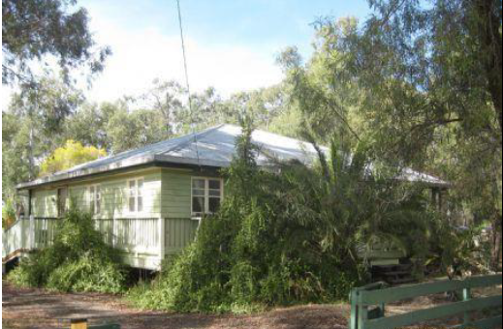
PHOTOGRAPHS OF DWELLING

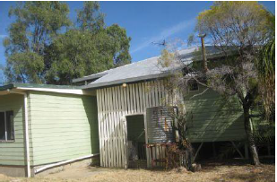

Rear of Building
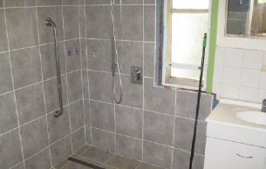
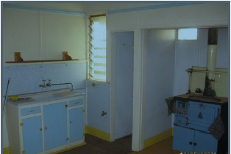

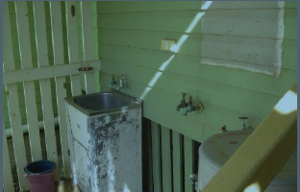
Kitchen Bathroom

Laundry
PLAN SHOWING RECONFIGURATION OF LOTS 1 & 2
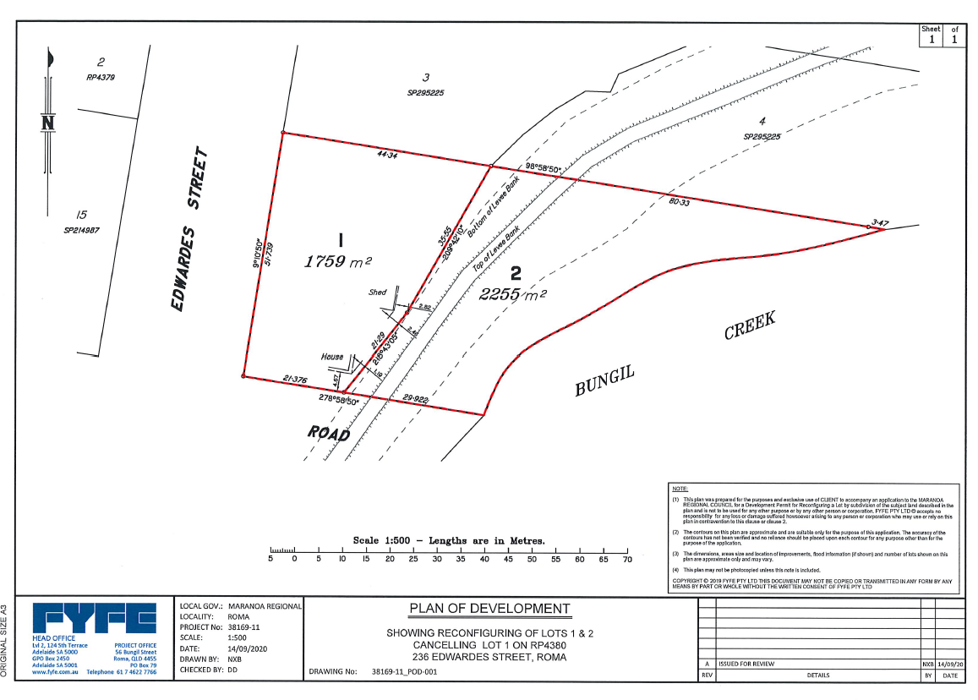
CANCELLING LOT 1 ON RP4380 – 236 EDWARDES STREET, ROMA

GOOGLE EARTH VIEW

SITE MAP OF FORMER LOT 1 ON RP4380
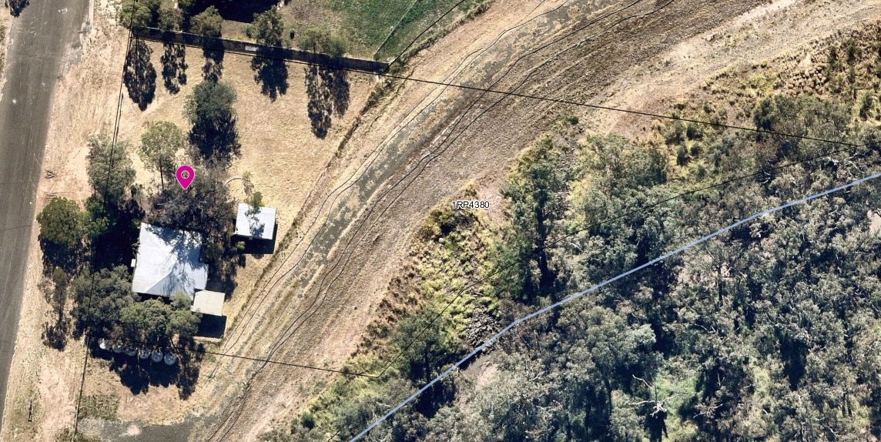

GENERAL DETAILS
To: Maranoa Regional Council

In response to Request for Tender:
23009 - 236 Edwardes Street NORTH, ROMA QLD 4455

1.1 Name of the company or entity or Individual under which this tender is being made. (Please state the full name including the corporate trustee and family trust, if applicable. e.g., ABC Pty Ltd as trustee for the XYZ Family Trust)

1.2 Trading name (if different)

1.3 State the type of entity (e.g., individual, public or private company or joint venture)

1.4 State of registration of company (if applicable)

1.5 ABN

1.7 Is the Tenderer registered under the GST Act?
☐ | No
☐ | Yes

1.9 Postal Address

1.10 Business/Personal Address

1.11 Telephone Number

1.12 Email Address

1.14 Nominated Person for Post-Tender Enquiries (full name, position and email)

ACKNOWLEDGEMENT AND ACCEPTANCE OF DOCUMENTS

I have read and understood Part 1 and Part 2 of the Tender documents. | ☐ Yes ☐ No

EXECUTION OF TENDER

I certify that:
- the information provided is true and correct,
- all terms used in this Tender Response bear the meanings assigned to them in Parts 1 and 2 as the case may be.
- this Tender Response is irrevocable for the period stated in the Invitation to Tender, unless extended by mutual agreement between the Tenderer and Council.

Signed for (the Tenderer) by an authorised officer in the presence of:
 |  | Signature of authorised officer
Signature of witness |  | Name of authorised officer (print)
Name of witness (print) |  | Position held by authorised officer
Date |  | Date

EVALUATION CRITERIA EVIDENCE
Council will be evaluating Tender Responses based on the following criteria:
  - Declaration of Actual, Potential or Perceived Conflicts of Interest Compulsory
  - Purchase Price Offered to Council 100 points

5.1 Declaration of Actual, Potential or Perceived Conflicts of Interest (Clause 17.0 – Conditions of Tender) | Compulsory Completion of the below Section
DECLARATION OF ACTUAL, POTENTIAL OR PERCEIVED CONFLICTS OF INTEREST
(Clause 17.0 – Conditions of Tender)

A Conflict of Interest is something that may impact your objectivity in performing your obligations to Council. An actual Conflict of Interest is:

- a personal advantage (or avoidance of loss), financial or otherwise, to a Council employee or their partner, spouse, immediate relative or friend; and/or

- where a Tenderer has other personal or business interests that may create a risk to, or impact on, the delivery of the goods and services, the subject of this tender, in accordance with Council’s requirements.

Please note that tenderers, including the successful Tenderer, must not pay any commission, fees, rebates, gifts or entertainment to any officer or agent of Council. Further, tenderers are to advise of any personal business arrangement with anyone involved with Council. This includes payments, gifts or business arrangements with a partner, spouse, immediate relative or friend of a Council employee.

The key to deciding whether there is an actual or potential conflict of interest is to think of how others might view you in the performance of your responsibilities under this Agreement. There may be a potential or perceived conflict of interest, or there may be an actual conflict of interest.

If you have a partner, spouse, immediate relative or friend who is a Council employee please declare this in Section 5.1 so that Council can consider if / how this potential, perceived or actual conflict can be managed.

5.1 Will any actual, perceived or potential conflict of interest in the performance of the Tenderers’ obligations under the Agreement exist if the Tenderer is awarded the Agreement, or are any such conflicts likely to arise during the Agreement?
☐ | No |  | Go to Next Section 5.2 - Price
☐ | Yes |  | Provide details and how the conflict is proposed to be dealt with and then Go to Section 5.2 - Price

5.2 PRICE OFFERED TO COUNCIL | 100 Points

5.3 (a) | What is the PURCHASE PRICE (GST Inclusive) offered to Council?  $

